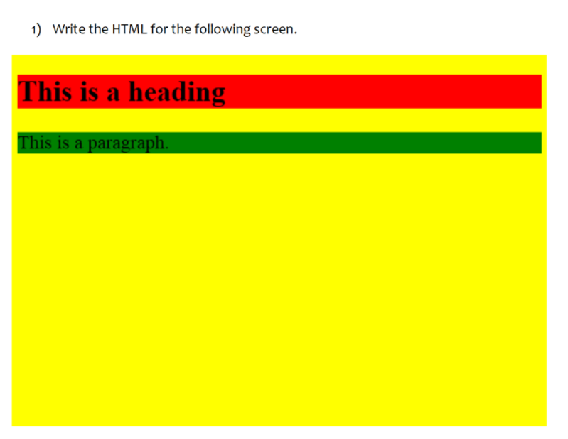

<!DOCTYPE html>

<html>

    <body style="background-color:Yellow">

        <h1 style="background-color:Red">This is a hedding</h1>

        <h3 style="background-color:green">This is a paragraph.</h1>

    </body>

</html>

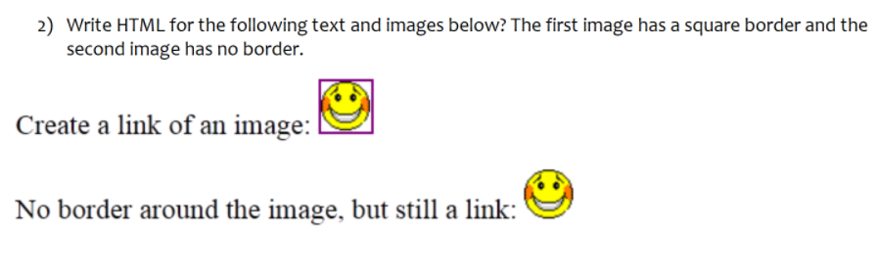

<!DOCTYPE html>

<html>

    <body style>

        <label for="image1">Create a link of an image:</label>

        <img src="squareborder.jpg" id="image1" value=image1>

        <br>

        <label for="image2">No border around the image, but still a link:</label>

        <img src="without border.jpg" id="image2" value="image">

    </body>

</html>

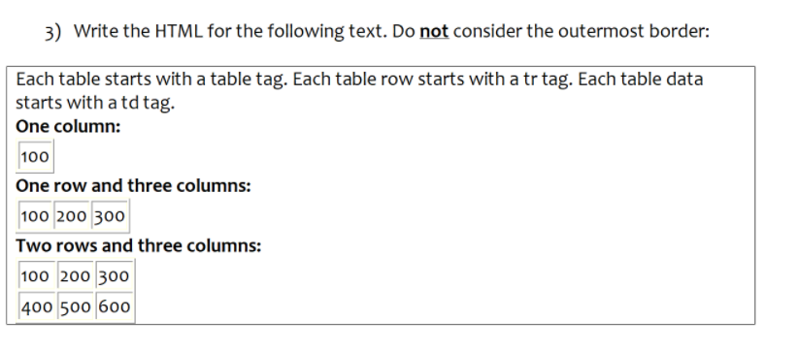

<!DOCTYPE html>

<html>

    <head>

        <style>

        table,td{

            border:1px solid black;

            border-collapse:collapse;

        }

        </style>

    </head>

    <body>

        <p>Each table starts with a table tag. Each table rows starts with a tr tag. Each table data starts with a td tag.</p>

        <p><strong>One column:</strong></p>

        <table>

            <tr>

                <td>100</td>

            </tr>

        </table>

        <p><strong>One row three columns:</strong></p>

        <table>

            <tr>

                <td>100</td>

                <td>200</td>

                <td>300</td>

            </tr>

        </table>

        <p><strong>Two rows three columns</strong></p>

        <table>

            <tr>

                <td>100</td>

                <td>200</td>

                <td>300</td>

            </tr>

            <tr>

                <td>400</td>

                <td>500</td>

                <td>600</td>

            </tr>

        </table>

    </body>

</html>

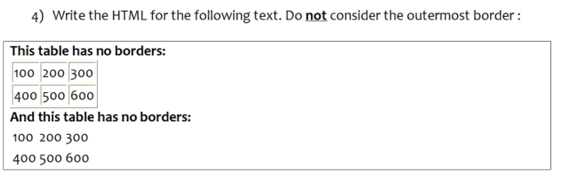

<!DOCTYPE html>

<html>

    <body>

        <p><strong>This table has no borders:</strong></p>

        <table style="border:1px solid black;border-collapse:collapse;">

            <tr style="border:1px solid black;">

                <td style="border:1px solid black;">100</td>

                <td style="border:1px solid black;">200</td>

                <td style="border:1px solid black;">300</td>

            </tr>

            <tr>

                <td style="border:1px solid black;">400</td>

                <td style="border:1px solid black;">500</td>

                <td style="border:1px solid black;">600</td>

            </tr>

        </table>

        <p><strong>And this table has no borders:</strong></p>

        <table>

            <tr>

                <td>100</td>

                <td>200</td>

                <td>300</td>

            </tr>

            <tr>

                <td>400</td>

                <td>500</td>

                <td>600</td>

            </tr>

        </table>

    </body>

</html>

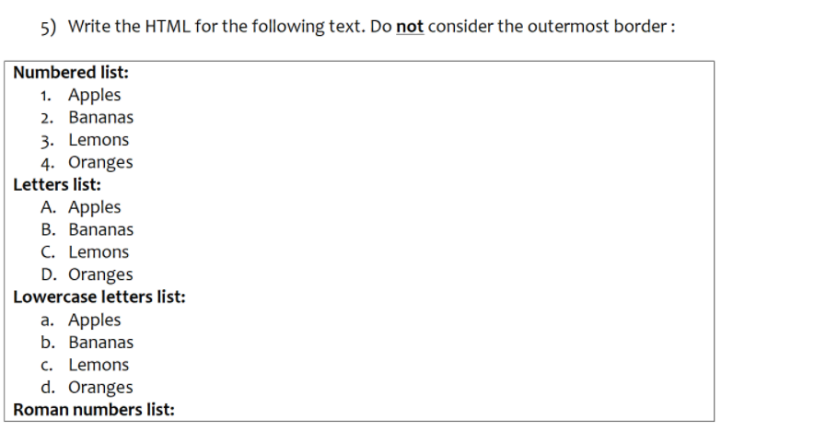

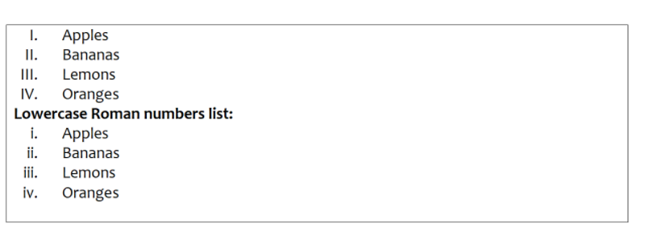

<!DOCTYPE html>

<html>

    <body>

        <p><strong>Numbered list:</strong></p>

        <ol type="1">

            <LI>Apples</LI>

            <LI>Bananas</LI>

            <LI>Lemons</LI>

            <LI>Oranges</LI>

        </ol>

        <p><strong>Letters list:</strong></p>

        <ol type="A">

            <LI>Apples</LI>

            <LI>Bananas</LI>

            <LI>Lemons</LI>

            <LI>Oranges</LI>

        </ol>

        <p><strong>Lowercase letters list:</strong></p>

        <ol type="a">

            <LI>Apples</LI>

            <LI>Bananas</LI>

            <LI>Lemons</LI>

            <LI>Oranges</LI>

        </ol>

        <p><strong>Roman numbers list:</strong></p>

        <ol type="I">

            <LI>Apples</LI>

            <LI>Bananas</LI>

            <LI>Lemons</LI>

            <LI>Oranges</LI>

        </ol>

        <p><strong>Lowercase Roman numbers list:</strong></p>

        <ol type="i">

            <LI>Apples</LI>

            <LI>Bananas</LI>

            <LI>Lemons</LI>

            <LI>Oranges</LI>

        </ol>

    </body>

</html>

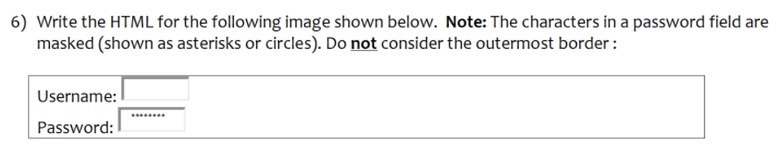

<!DOCTYPE html>

<html>

    <body>

        <form action="">

            <label for="username">Username:</label>

            <input type="username"id="username"value="username"><br>

            <br>

            <label for="passward">Passward:</label>

            <input type="passward"id="passward"value="\*\*\*\*\*\*"><br>

        </form>

    </body>

</html>

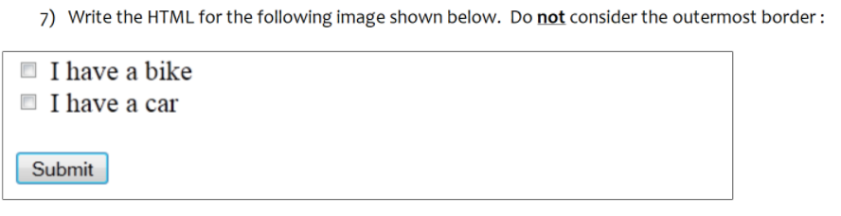

<!DOCTYPE html>

<html>

    <body>

        <form action ="submit">

            <input type="checkbox">

            <label for="vehicle1">I have a bike</label><br>

            <input type="checkbox">

            <label for="vehicle2">I have a car</label><br>

            <br>

            <input type="submit"value="submit">

        </form>

    </body>

</html>

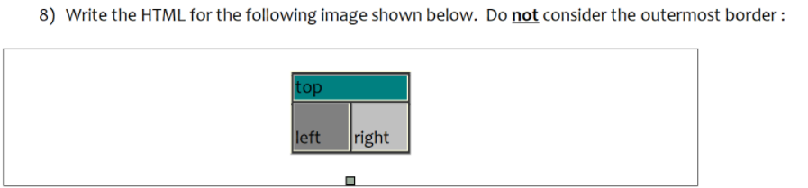

<!DOCTYPE html>

<html>

    <body>

        <table style="border:2px solid black;border-collapse:collapse;">

            <tr row span ="2" style="background-color:green">>

                <th>top</th>

            </tr>

            <tr style="border: ipx solid black;">

                <td style="border:2px solid black;” "background-color:lightslategrey;">Left</td>

                <td style="border:2px solid black;” "background-color:darkgrey;">Right</td>

            </tr>

        </table>

    </body>

</html>

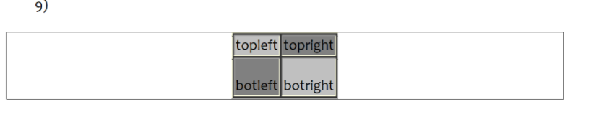

<!DOCTYPE html>

<html>

    <head>

        <style>

            table,td{

                border:1px solid black;

                border-collapse:collapse;

            }

        </style>

        <body>

            <table>

                <tr>

                    <td background-color="grey">topleft</td>

                    <td background-color="darkgrey">topright</td>

                </tr>

                <tr>

                    <td background-color="darkgrey">botleft</td>

                    <td background-color="grey">botright</td>

                </tr>

            </table>

        </body>

    </head>

</html>